ELECTRICITY CONSUMPTION ANALYSIS PROJECT REPORT

1. INTRODUCTION
1.1 Project Overview
Electricity Consumption Analysis is a data analytics project designed to study and interpret electricity usage patterns over time. The system processes historical electricity consumption data and presents it through interactive dashboards. It helps users understand daily, monthly, and seasonal consumption trends across residential, commercial, or industrial sectors.
1.2 Purpose
The primary purpose of this project is to minimize energy wastage and reduce electricity costs by providing meaningful insights from consumption data. It also assists utility providers and policymakers in demand forecasting and energy planning.

2. IDEATION PHASE
2.1 Problem Statement
Most electricity consumers receive only monthly bills, which do not provide detailed insights into consumption behavior. This lack of visibility leads to inefficient usage, high electricity bills, and difficulty in identifying peak demand periods.
2.2 Empathy Map Canvas
Users often think about why their electricity bills are increasing and feel concerned about energy wastage. They want an easy way to monitor usage and take corrective actions. Currently, users manually compare bills or reduce appliance usage without data-driven guidance.
2.3 Brainstorming
During brainstorming, multiple ideas were generated such as visual dashboards, peak vs off-peak analysis, comparative usage reports, and alert mechanisms for abnormal consumption. The most feasible ideas were selected based on simplicity and effectiveness.

3. REQUIREMENT ANALYSIS
3.1 Customer Journey Map
The user journey begins with collecting electricity consumption data, followed by uploading the data into the system. The system processes the data and displays insights through dashboards. Based on these insights, users can modify their energy usage behavior.
3.2 Solution Requirement
The system should provide accurate and reliable data analysis, easy-to-understand visualizations, and flexible filtering options. It must support different time ranges and consumption categories.
3.3 Data Flow Diagram
Electricity data is collected from meters or datasets and passed through preprocessing stages such as cleaning and aggregation. The processed data is stored in a database and analyzed before being visualized on dashboards.
3.4 Technology Stack
Python is used for data preprocessing and analysis. Tableau is used to design interactive dashboards. CSV files and MySQL databases are used for storing electricity consumption data.

4. PROJECT DESIGN
4.1 Problem–Solution Fit
The proposed system directly addresses the problem of poor consumption visibility by transforming raw electricity data into actionable insights. This enables users to identify inefficiencies and optimize energy usage.
4.2 Proposed Solution
The project proposes a data-driven electricity consumption analysis platform that provides trend analysis, peak usage identification, and comparative insights through interactive dashboards.
4.3 Solution Architecture
The solution architecture follows a layered approach consisting of data source, data ingestion, data processing, data storage, analytics, and visualization layers. This design ensures scalability, accuracy, and ease of maintenance.

5. PROJECT PLANNING & SCHEDULING
5.1 Project Planning
The project was executed in phases including requirement analysis, data collection, data preprocessing, dashboard development, testing, and final deployment. Each phase was planned to ensure timely and systematic completion.

6. FUNCTIONAL AND PERFORMANCE TESTING
6.1 Performance Testing
The system was tested using large datasets to ensure efficient processing and quick dashboard response times. The accuracy of calculated consumption values and visual outputs was also validated.

7. RESULTS
7.1 Output Screenshots
The final output includes dashboards showing electricity consumption trends, peak demand periods, and monthly or yearly comparisons. These visuals provide clear and actionable insights for users.

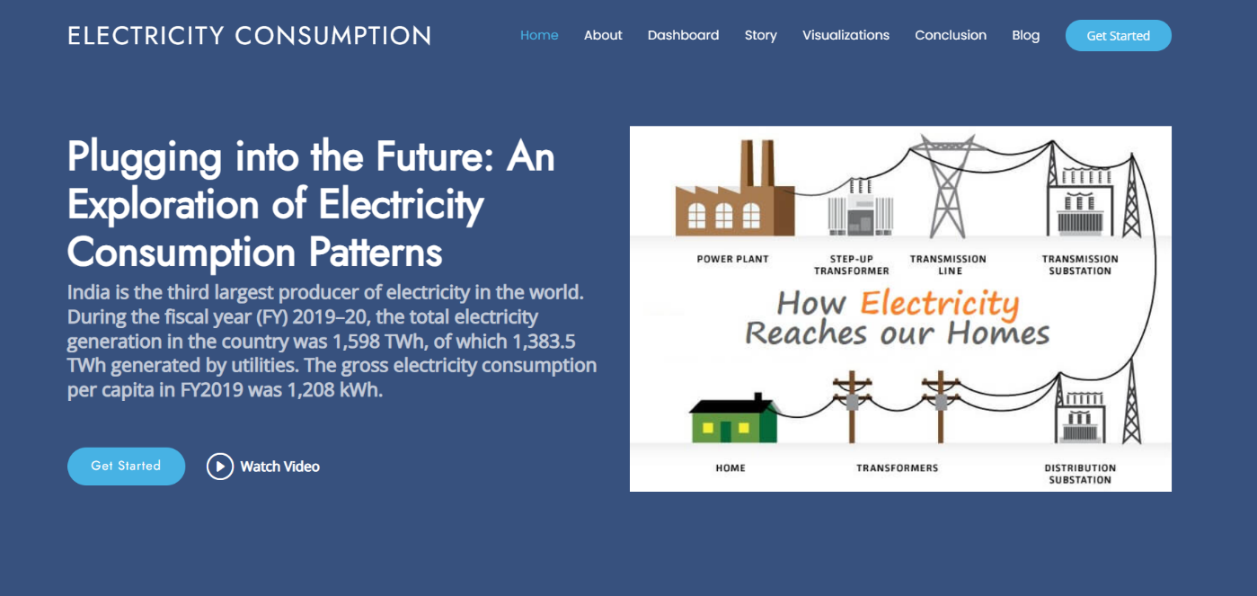

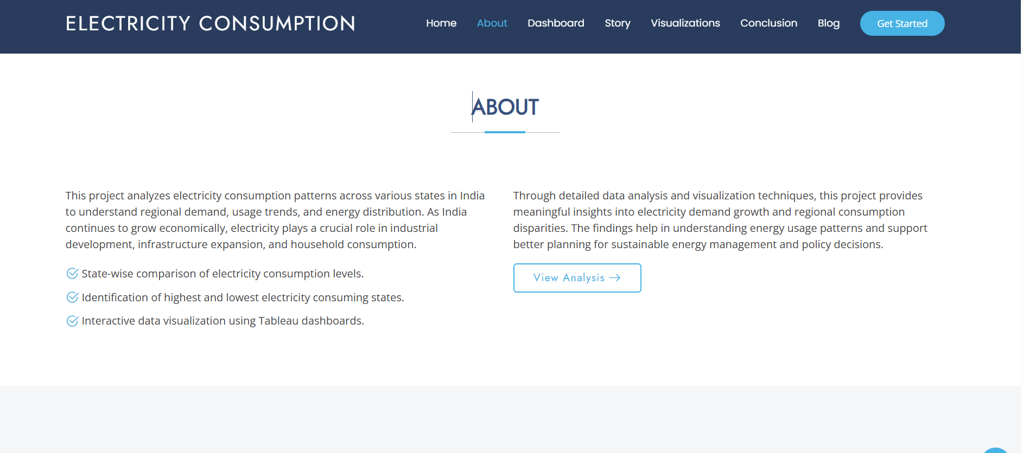

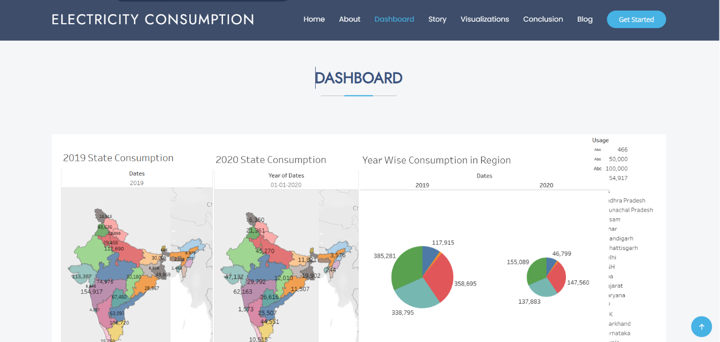

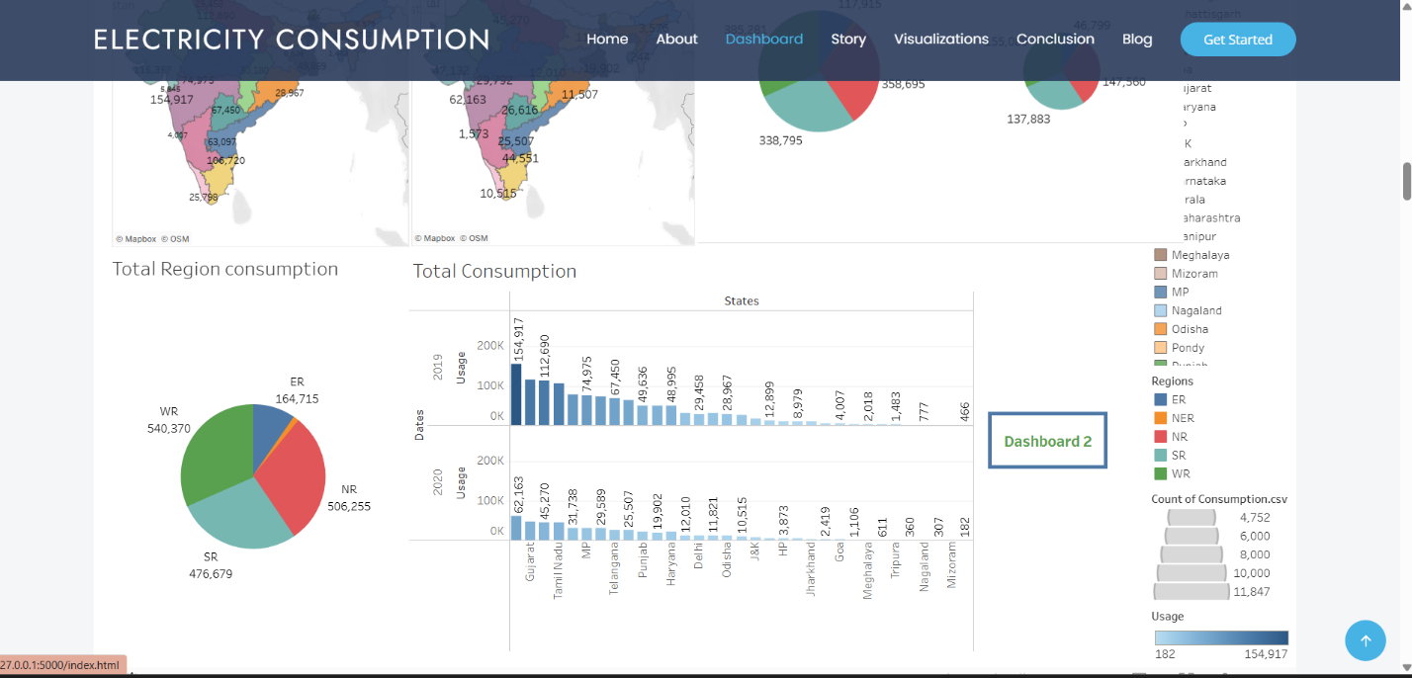

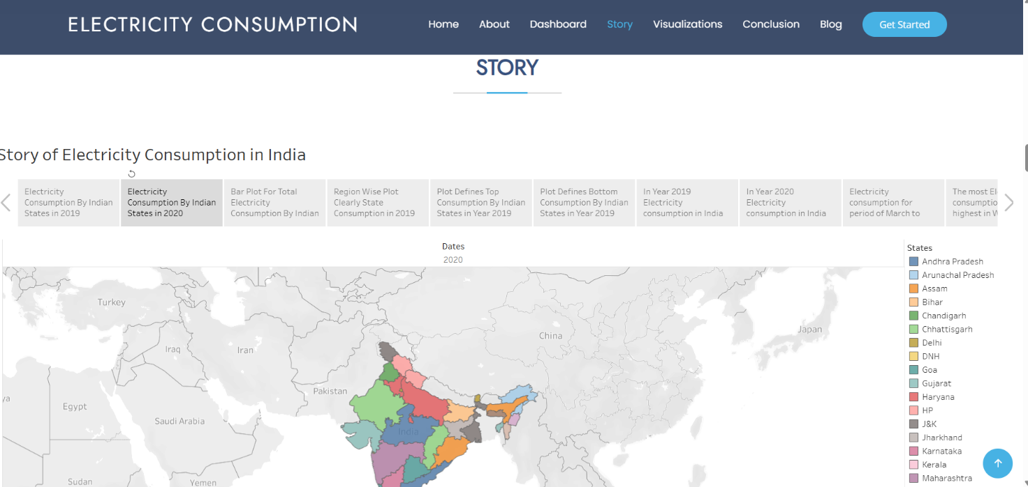

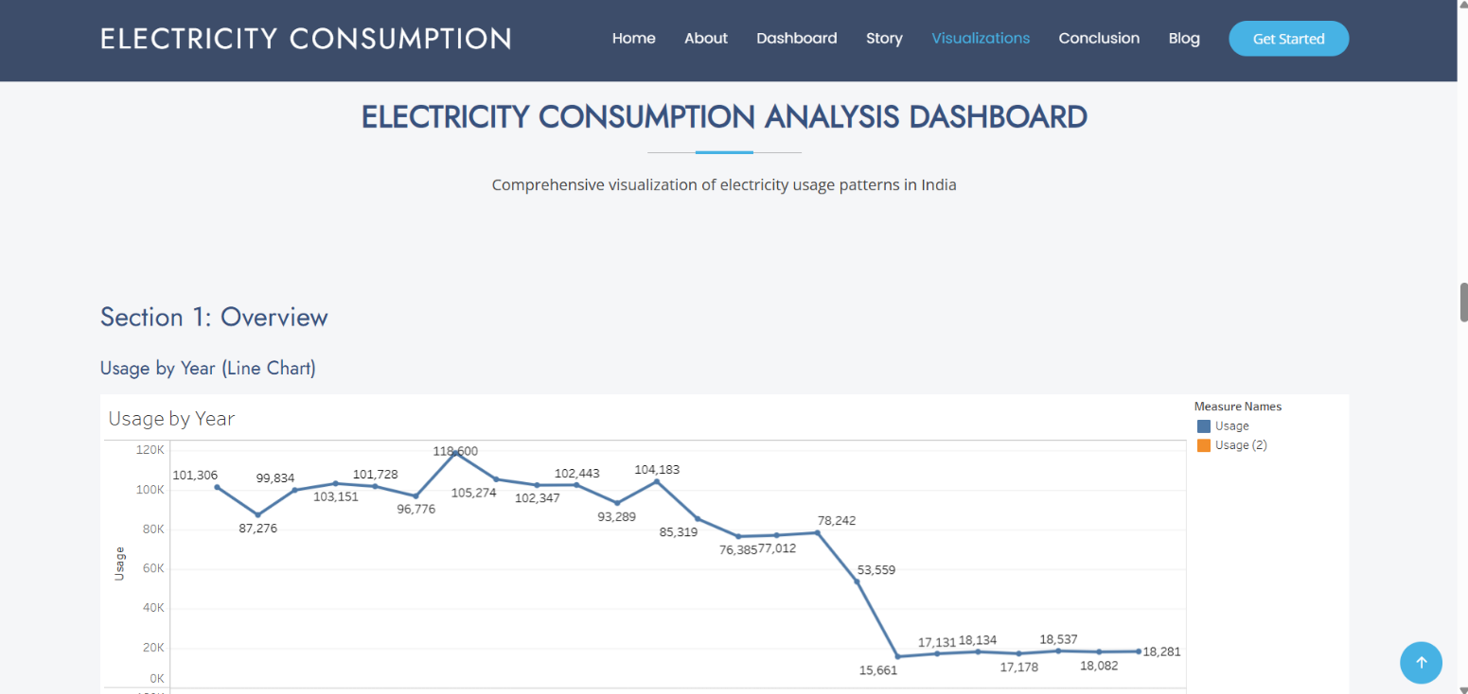
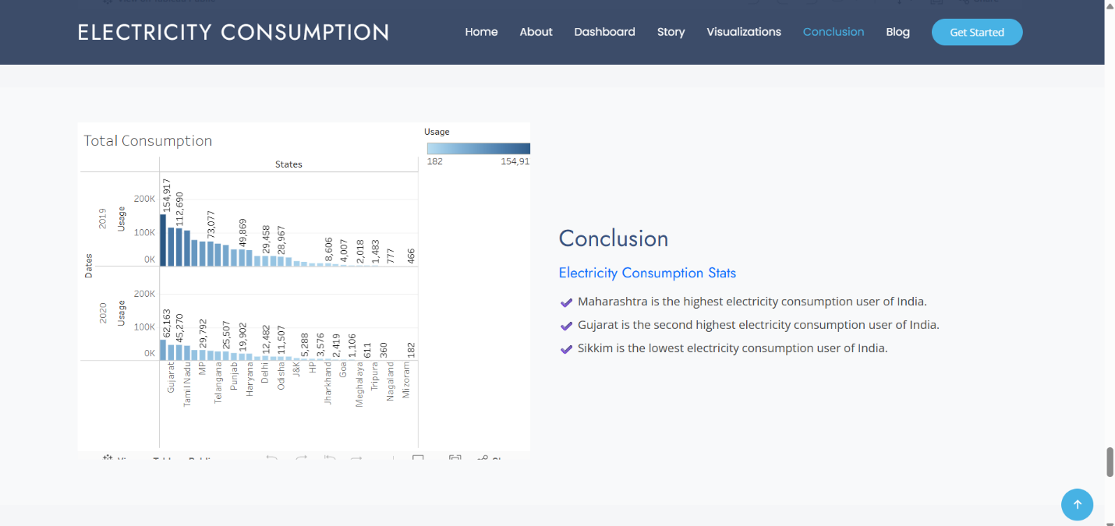

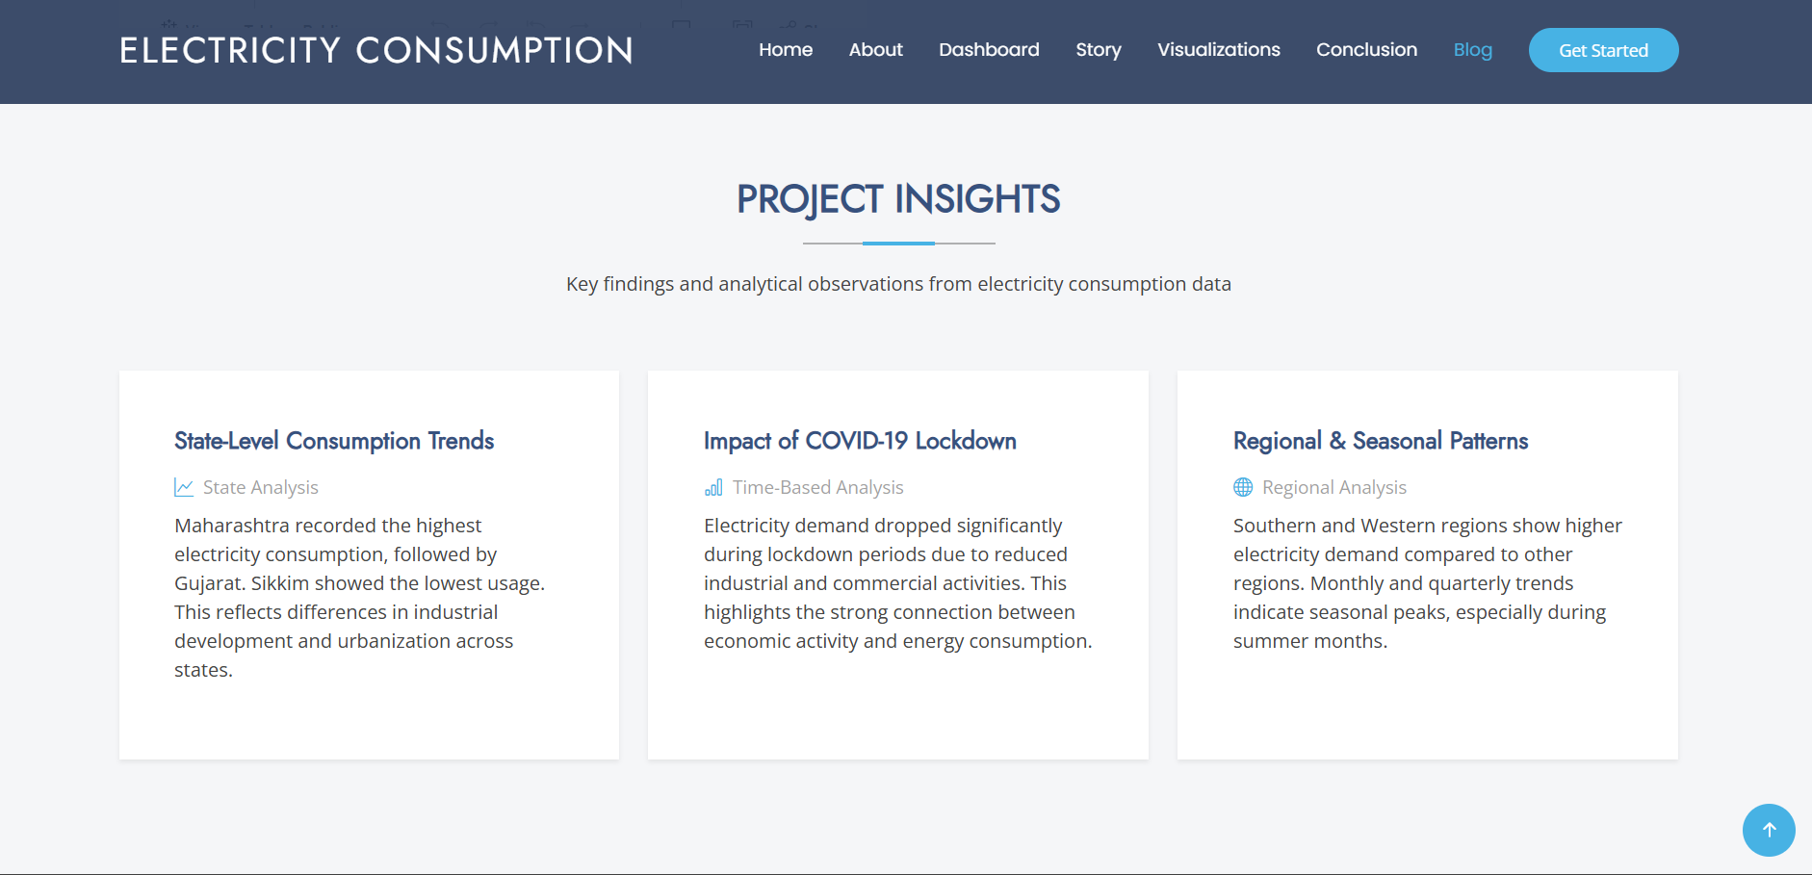

8. ADVANTAGES & DISADVANTAGES
Advantages
- Provides clear visibility into electricity consumption
- Helps reduce energy costs and wastage
- Supports data-driven decision making
Disadvantages
- Requires accurate input data
- Real-time analysis depends on smart meter availability

9. CONCLUSION
The Electricity Consumption Analysis project successfully demonstrates how data analytics and visualization can improve energy awareness. The system enables users to understand their consumption behavior and take steps toward efficient energy usage.

10. FUTURE SCOPE
Future enhancements include real-time data integration using smart meters, predictive analytics using machine learning, mobile application support, and automated energy-saving recommendations.

11. APPENDIX
Source Code:
<!DOCTYPE html>
<html lang="en">

<head>
<meta charset="utf-8">
<meta content="width=device-width, initial-scale=1.0" name="viewport">
<title>Index - Arsha Bootstrap Template</title>
<meta name="description" content="">
<meta name="keywords" content="">

<!-- Favicon -->
<link rel="icon" href="{{ url_for('static', filename='assets/img/favicon.png') }}">
<link rel="apple-touch-icon" href="{{ url_for('static', filename='assets/img/apple-touch-icon.png') }}">

<!-- Fonts -->
<link href="https://fonts.googleapis.com" rel="preconnect">
<link href="https://fonts.gstatic.com" rel="preconnect" crossorigin>
<link href="https://fonts.googleapis.com/css2?family=Open+Sans&family=Poppins&family=Jost&display=swap" rel="stylesheet">

<!-- Vendor CSS Files -->
<link href="{{ url_for('static', filename='assets/vendor/bootstrap/css/bootstrap.min.css') }}" rel="stylesheet">
<link href="{{ url_for('static', filename='assets/vendor/bootstrap-icons/bootstrap-icons.css') }}" rel="stylesheet">
<link href="{{ url_for('static', filename='assets/vendor/aos/aos.css') }}" rel="stylesheet">
<link href="{{ url_for('static', filename='assets/vendor/glightbox/css/glightbox.min.css') }}" rel="stylesheet">
<link href="{{ url_for('static', filename='assets/vendor/swiper/swiper-bundle.min.css') }}" rel="stylesheet">

<!-- Main CSS File -->
<link href="{{ url_for('static', filename='assets/css/main.css') }}" rel="stylesheet">

</head>

<body class="index-page">

<header id="header" class="header d-flex align-items-center fixed-top">
<div class="container-fluid container-xl position-relative d-flex align-items-center">

<a href="index.html" class="logo d-flex align-items-center me-auto">
<!-- Uncomment the line below if you also wish to use an image logo -->
<!-- <img src="assets/img/logo.webp" alt=""> -->
<h1 class="sitename">Electricity Consumption</h1>
</a>

<nav id="navmenu" class="navmenu">
<ul>
<li><a href="#hero" class="active">Home</a></li>
<li><a href="#about">About</a></li>
<li><a href="#services">Dashboard</a></li>
<li><a href="#portfolio">Story</a></li>
<li><a href="#visualizations">Visualizations</a></li>
<li><a href="#conclusion">Conclusion</a></li>
<li><a href="#recent-blog-postst">Blog</a></li>
</ul>
<i class="mobile-nav-toggle d-xl-none bi bi-list"></i>
</nav>

<a class="btn-getstarted" href="#about">Get Started</a>

</div>
</header>

<main class="main">

<!-- Hero Section -->
<section id="hero" class="hero section dark-background">

<div class="container">
<div class="row gy-4">
<div class="col-lg-6 order-2 order-lg-1 d-flex flex-column justify-content-center" >
<h1>Plugging into the Future: An Exploration of Electricity Consumption Patterns </h1>
<p> India is the third largest producer of electricity in the world.
During the fiscal year (FY) 2019–20, the total electricity generation
in the country was 1,598 TWh, of which 1,383.5 TWh generated by utilities.
The gross electricity consumption per capita in FY2019 was 1,208 kWh.

</p>
<div class="d-flex mt-4">
<a href="#about" class="btn-get-started">Get Started</a>
<a href="https://www.youtube.com/watch?v=Y7f98aduVJ8" class="glightbox btn-watch-video d-flex align-items-center"><i class="bi bi-play-circle"></i><span>Watch Video</span></a>
</div>
</div>
<div class="col-lg-6 order-1 order-lg-2 hero-img">
<img src="https://electricalfundablog.com/wp-content/uploads/2020/09/How-Electricity-Reaches-our-Homes.jpg" class="img-fluid" alt="">
</div>
</div>
</div>

</section><!-- /Hero Section -->

<!-- About Section -->
<section id="about" class="about section">

<!-- Section Title -->
<div class="container section-title" data-aos="fade-up">
<h2>About</h2>
</div><!-- End Section Title -->

<div class="container">

<div class="row gy-4">

<!-- <div class="col-lg-6 content" data-aos="fade-up" data-aos-delay="100">
<p>
Lorem ipsum dolor sit amet, consectetur adipiscing elit, sed do eiusmod tempor incididunt ut labore et dolore
magna aliqua.
</p>
<ul>
<li><i class="bi bi-check2-circle"></i> <span>Ullamco laboris nisi ut aliquip ex ea commodo consequat.</span></li>
<li><i class="bi bi-check2-circle"></i> <span>Duis aute irure dolor in reprehenderit in voluptate velit.</span></li>
<li><i class="bi bi-check2-circle"></i> <span>Ullamco laboris nisi ut aliquip ex ea commodo</span></li>
</ul>
</div>

<div class="col-lg-6" data-aos="fade-up" data-aos-delay="200">
<p>Ullamco laboris nisi ut aliquip ex ea commodo consequat. Duis aute irure dolor in reprehenderit in voluptate velit esse cillum dolore eu fugiat nulla pariatur. Excepteur sint occaecat cupidatat non proident, sunt in culpa qui officia deserunt mollit anim id est laborum. </p>
<a href="#" class="read-more"><span>Read More</span><i class="bi bi-arrow-right"></i></a>
</div> -->
<div class="col-lg-6 content" data-aos="fade-up" data-aos-delay="100">
<p>
This project analyzes electricity consumption patterns across various
states in India to understand regional demand, usage trends, and
energy distribution. As India continues to grow economically,
electricity plays a crucial role in industrial development,
infrastructure expansion, and household consumption.
</p>

<ul>
<li><i class="bi bi-check2-circle"></i>
<span>State-wise comparison of electricity consumption levels.</span>
</li>
<li><i class="bi bi-check2-circle"></i>
<span>Identification of highest and lowest electricity consuming states.</span>
</li>
<li><i class="bi bi-check2-circle"></i>
<span>Interactive data visualization using Tableau dashboards.</span>
</li>
</ul>
</div>

<div class="col-lg-6" data-aos="fade-up" data-aos-delay="200">
<p>
Through detailed data analysis and visualization techniques, this project
provides meaningful insights into electricity demand growth and regional
consumption disparities. The findings help in understanding energy usage
patterns and support better planning for sustainable energy management
and policy decisions.
</p>

<a href="#conclusion" class="read-more">
<span>View Analysis</span>
<i class="bi bi-arrow-right"></i>
</a>
</div>

</div>

</div>

</section><!-- /About Section -->

<section id="why-us" class="section why-us light-background">

<div class="container-fluid">
<div class="row gy-4">

<div class="col-lg-7 d-flex flex-column justify-content-center order-2 order-lg-1">

<div class="content px-xl-5" data-aos="fade-up" data-aos-delay="100">
<h3>
<span>Why Electricity Consumption Analysis is Important </span>
<strong>for Sustainable Growth</strong>
</h3>
<p>
Electricity plays a vital role in economic development, industrial expansion,
and improving living standards. Understanding consumption patterns helps
governments and policymakers plan efficient energy distribution and
ensure sustainable resource management.
</p>
</div>

<div class="faq-container px-xl-5" data-aos="fade-up" data-aos-delay="200">

<!-- FAQ 1 -->
<div class="faq-item faq-active">
<h3><span>01</span> Why analyze state-wise electricity consumption?</h3>
<div class="faq-content">
<p>
State-wise analysis helps identify regions with high and low electricity usage.
It supports better allocation of resources and improves infrastructure planning
based on regional demand.
</p>
</div>
<i class="faq-toggle bi bi-chevron-right"></i>
</div>

<!-- FAQ 2 -->
<div class="faq-item">
<h3><span>02</span> How does data visualization improve understanding?</h3>
<div class="faq-content">
<p>
Interactive dashboards and visual charts make complex electricity data
easier to interpret. They allow users to compare trends, detect patterns,
and draw meaningful insights efficiently.
</p>
</div>
<i class="faq-toggle bi bi-chevron-right"></i>
</div>

<!-- FAQ 3 -->
<div class="faq-item">
<h3><span>03</span> What are the key outcomes of this project?</h3>
<div class="faq-content">
<p>
The project identifies Maharashtra as the highest electricity consumer,
Gujarat as the second highest, and Sikkim as the lowest. These insights
highlight regional differences in energy demand across India.
</p>
</div>
<i class="faq-toggle bi bi-chevron-right"></i>
</div>

</div>

</div>

<!-- Right Image -->
<div class="col-lg-5 order-1 order-lg-2 why-us-img">
<img src="https://cdn-icons-png.flaticon.com/512/1995/1995501.png"
class="img-fluid"
alt="Electricity Analysis">
</div>

</div>
</div>

</section>

<!-- Skills Section -->
<!-- Skills Section -->
<section id="skills" class="skills section">

<div class="container" data-aos="fade-up" data-aos-delay="100">

<div class="row">

<!-- LEFT IMAGE -->
<div class="col-lg-6 d-flex align-items-center">
<img src="https://cdn-icons-png.flaticon.com/512/2721/2721291.png"
class="img-fluid"
alt="Data Analysis Illustration">
</div>

<!-- RIGHT CONTENT -->
<div class="col-lg-6 pt-4 pt-lg-0 content">

<h3>Technologies & Analysis Strengths</h3>
<p class="fst-italic">
This project applies analytical techniques and visualization tools
to understand electricity consumption trends across Indian states.
</p>

<div class="skills-content skills-animation">

<!-- Data Analysis -->
<div class="progress">
<span class="skill">
<span>Data Analysis & Interpretation</span>
<i class="val">92%</i>
</span>
<div class="progress-bar-wrap">
<div class="progress-bar"
role="progressbar"
aria-valuenow="92"
aria-valuemin="0"
aria-valuemax="100"></div>
</div>
</div>

<!-- Tableau -->
<div class="progress">
<span class="skill">
<span>Tableau Dashboard Development</span>
<i class="val">95%</i>
</span>
<div class="progress-bar-wrap">
<div class="progress-bar"
role="progressbar"
aria-valuenow="95"
aria-valuemin="0"
aria-valuemax="100"></div>
</div>
</div>

<!-- Frontend -->
<div class="progress">
<span class="skill">
<span>Frontend Design (HTML, CSS, Bootstrap)</span>
<i class="val">85%</i>
</span>
<div class="progress-bar-wrap">
<div class="progress-bar"
role="progressbar"
aria-valuenow="85"
aria-valuemin="0"
aria-valuemax="100"></div>
</div>
</div>

<!-- Research -->
<div class="progress">
<span class="skill">
<span>Research & Insight Generation</span>
<i class="val">88%</i>
</span>
<div class="progress-bar-wrap">
<div class="progress-bar"
role="progressbar"
aria-valuenow="88"
aria-valuemin="0"
aria-valuemax="100"></div>
</div>
</div>

</div>

</div>
</div>

</div>

</section>
<!-- End Skills Section -->

<!-- /Skills Section -->

<!-- Services Section -->
<section id="services" class="services section light-background">

<!-- Section Title -->
<div class="container section-title" data-aos="fade-up">
<h2>Dashboard</h2>

</div><!-- End Section Title -->

<div class="container">

<div class='tableauPlaceholder' id='viz1771420493751' style='position: relative'><noscript><a href='#'><img alt='Dashboard 1 ' src='https:&#47;&#47;public.tableau.com&#47;static&#47;images&#47;pr&#47;proj1_17714129347370&#47;Dashboard1&#47;1_rss.png' style='border: none' /></a></noscript><object class='tableauViz' style='display:none;'><param name='host_url' value='https%3A%2F%2Fpublic.tableau.com%2F' /> <param name='embed_code_version' value='3' /> <param name='site_root' value='' /><param name='name' value='proj1_17714129347370&#47;Dashboard1' /><param name='tabs' value='no' /><param name='toolbar' value='yes' /><param name='static_image' value='https:&#47;&#47;public.tableau.com&#47;static&#47;images&#47;pr&#47;proj1_17714129347370&#47;Dashboard1&#47;1.png' /> <param name='animate_transition' value='yes' /><param name='display_static_image' value='yes' /><param name='display_spinner' value='yes' /><param name='display_overlay' value='yes' /><param name='display_count' value='yes' /><param name='language' value='en-US' /><param name='filter' value='publish=yes' /></object></div> <script type='text/javascript'> var divElement = document.getElementById('viz1771420493751'); var vizElement = divElement.getElementsByTagName('object')[0]; if ( divElement.offsetWidth > 800 ) { vizElement.style.width='100%';vizElement.style.height=(divElement.offsetWidth*0.75)+'px';} else if ( divElement.offsetWidth > 500 ) { vizElement.style.width='100%';vizElement.style.height=(divElement.offsetWidth*0.75)+'px';} else { vizElement.style.width='100%';vizElement.style.height='1877px';} var scriptElement = document.createElement('script'); scriptElement.src = 'https://public.tableau.com/javascripts/api/viz_v1.js'; vizElement.parentNode.insertBefore(scriptElement, vizElement); </script>

</div>

</section><!-- /Call To Action Section -->

<!-- Portfolio Section -->
<section id="portfolio" class="portfolio section">

<!-- Section Title -->
<div class="container section-title" data-aos="fade-up">
<h2>Story</h2>

</div><!-- End Section Title -->

<div class='tableauPlaceholder' id='viz1771422826981' style='position: relative'><noscript><a href='#'><img alt='Story of Electricity Consumption in India ' src='https:&#47;&#47;public.tableau.com&#47;static&#47;images&#47;47&#47;47N6MGHXF&#47;1_rss.png' style='border: none' /></a></noscript><object class='tableauViz' style='display:none;'><param name='host_url' value='https%3A%2F%2Fpublic.tableau.com%2F' /> <param name='embed_code_version' value='3' /> <param name='path' value='shared&#47;47N6MGHXF' /> <param name='toolbar' value='yes' /><param name='static_image' value='https:&#47;&#47;public.tableau.com&#47;static&#47;images&#47;47&#47;47N6MGHXF&#47;1.png' /> <param name='animate_transition' value='yes' /><param name='display_static_image' value='yes' /><param name='display_spinner' value='yes' /><param name='display_overlay' value='yes' /><param name='display_count' value='yes' /><param name='language' value='en-US' /><param name='filter' value='publish=yes' /></object></div> <script type='text/javascript'> var divElement = document.getElementById('viz1771422826981'); var vizElement = divElement.getElementsByTagName('object')[0]; vizElement.style.width='100%';vizElement.style.height=(divElement.offsetWidth*0.75)+'px'; var scriptElement = document.createElement('script'); scriptElement.src = 'https://public.tableau.com/javascripts/api/viz_v1.js'; vizElement.parentNode.insertBefore(scriptElement, vizElement); </script>
</div><!-- End Portfolio Item -->

</div>

</section><!-- /Portfolio Section -->

<!-- Pricing Section -->

<!-- ================= VISUALIZATION DASHBOARD ================= -->

<section id="visualizations" class="section light-background">

<div class="container">

<div class="section-title text-center">
<h2>Electricity Consumption Analysis Dashboard</h2>
<p>Comprehensive visualization of electricity usage patterns in India</p>
</div>

<!-- ================= SECTION 1: OVERVIEW ================= -->

<div class="mt-5">
<h3 class="mb-4">Section 1: Overview</h3>

<h5 class="mb-3">Usage by Year (Line Chart)</h5>
<div id="usageYear" class="tableau-container mb-5"></div>
</div>

<!-- ================= SECTION 2: STATE ANALYSIS ================= -->

<div class="mt-5">
<h3 class="mb-4">Section 2: State Analysis</h3>

<h5 class="mb-3">2019 vs 2020 State Comparison</h5>
<div id="stateComparison" class="tableau-container mb-5"></div>

<h5 class="mb-3">Top N & Bottom N States</h5>
<div id="topBottom" class="tableau-container mb-5"></div>
</div>
<!-- ================= SECTION 3: REGIONAL ANALYSIS ================= -->

<div class="mt-5">
<h3 class="mb-4">Section 3: Regional Analysis</h3>

<h5 class="mb-3">Region-wise Total Consumption</h5>
<div id="regionWise" class="tableau-container mb-5"></div>
</div>

<!-- ================= SECTION 4: TIME-BASED ANALYSIS ================= -->

<div class="mt-5">
<h3 class="mb-4">Section 4: Time-Based Analysis</h3>

<h5 class="mb-3">Month-wise Consumption (2019 vs 2020)</h5>
<div id="monthwise" class="tableau-container mb-5"></div>

<h5 class="mb-3">Quarter Usage</h5>
<div id="quarterUsage" class="tableau-container mb-5"></div>

<h5 class="mb-3">Before vs After Lockdown</h5>
<div id="lockdownUsage" class="tableau-container mb-5"></div>
</div>

</div>

</section>

<!-- ================= TABLEAU SCRIPT (LOAD ONLY ONCE) ================= -->

<script src="https://public.tableau.com/javascripts/api/viz_v1.js"></script>

<script>
function loadViz(containerId, vizName) {
var containerDiv = document.getElementById(containerId);

var vizHTML = `
<object class='tableauViz' width='100%' height='650'>
<param name='host_url' value='https://public.tableau.com/' />
<param name='embed_code_version' value='3' />
<param name='site_root' value='' />
<param name='name' value='${vizName}' />
<param name='tabs' value='no' />
<param name='toolbar' value='yes' />
</object>
`;

containerDiv.innerHTML = vizHTML;
}

loadViz("usageYear", "proj5_17714816605090/UsagebyYear");
loadViz("stateComparison", "proj4_17714815065420/2019vs2020StateComparison");
loadViz("topBottom", "proj3_17714814276230/TopNvsBottomN");
loadViz("regionWise", "proj8_17714833381390/RegionwiseStateConsumption");

loadViz("monthwise", "proj2_17714812039580/2019vs2020MonthwiseConsumption");

loadViz("quarterUsage", "proj6_17714827754100/Quaterwiseusage");
loadViz("lockdownUsage", "proj7_17714829698970/UsagebeforeandduringLockdown");
</script>

<section id="conclusion" class="py-5 bg-light">
<div class="container">
<div class="row align-items-center">

<!-- LEFT SIDE : TABLEAU DASHBOARD -->
<div class="col-md-6 mb-4 mb-md-0">

<div class='tableauPlaceholder' id='viz1771425716593' style='position: relative'>
<noscript>
<a href='#'>
<img alt='Total Consumption'
src='https://public.tableau.com/static/images/pr/projconclusion/TotalConsumption/1_rss.png'
style='border: none; width:100%;' />
</a>
</noscript>

<object class='tableauViz' style='display:none;'>
<param name='host_url' value='https://public.tableau.com/' />
<param name='embed_code_version' value='3' />
<param name='site_root' value='' />
<param name='name' value='projconclusion/TotalConsumption' />
<param name='tabs' value='no' />
<param name='toolbar' value='yes' />
<param name='static_image'
value='https://public.tableau.com/static/images/pr/projconclusion/TotalConsumption/1.png' />
<param name='animate_transition' value='yes' />
<param name='display_spinner' value='yes' />
<param name='display_overlay' value='yes' />
<param name='display_count' value='yes' />
<param name='language' value='en-US' />
</object>
</div>

</div>

<!-- RIGHT SIDE : CONCLUSION TEXT -->
<div class="col-md-6">
<h2 class="mb-3">Conclusion</h2>
<h5 class="mb-3 text-primary">Electricity Consumption Stats</h5>
<ul class="list-unstyled">
<li class="mb-2">✔ Maharashtra is the highest electricity consumption user of India.</li>
<li class="mb-2">✔ Gujarat is the second highest electricity consumption user of India.</li>
<li class="mb-2">✔ Sikkim is the lowest electricity consumption user of India.</li>
</ul>
</div>

</div>
</div>
</section>

<script type='text/javascript'>
var divElement = document.getElementById('viz1771425716593');
var vizElement = divElement.getElementsByTagName('object')[0];
vizElement.style.width = '100%';
vizElement.style.height = (divElement.offsetWidth * 0.75) + 'px';

var scriptElement = document.createElement('script');
scriptElement.src = 'https://public.tableau.com/javascripts/api/viz_v1.js';
vizElement.parentNode.insertBefore(scriptElement, vizElement);
</script>

<!-- Project Insights Section -->
<section id="recent-blog-postst" class="recent-blog-postst section light-background">

<!-- Section Title -->
<div class="container section-title text-center" data-aos="fade-up">
<h2>Project Insights</h2>
<p>Key findings and analytical observations from electricity consumption data</p>
</div>

<div class="container">
<div class="row gy-5">

<!-- Insight 1 -->
<div class="col-xl-4 col-md-6">
<div class="post-item position-relative h-100 shadow-sm p-3" data-aos="fade-up" data-aos-delay="100">

<div class="post-content d-flex flex-column">

<h3 class="post-title">State-Level Consumption Trends</h3>

<div class="meta d-flex align-items-center mb-2">
<i class="bi bi-graph-up"></i>
<span class="ps-2">State Analysis</span>
</div>

<p>
Maharashtra recorded the highest electricity consumption, followed by Gujarat.
Sikkim showed the lowest usage. This reflects differences in industrial
development and urbanization across states.
</p>

</div>

</div>
</div>

<!-- Insight 2 -->
<div class="col-xl-4 col-md-6">
<div class="post-item position-relative h-100 shadow-sm p-3" data-aos="fade-up" data-aos-delay="200">

<div class="post-content d-flex flex-column">

<h3 class="post-title">Impact of COVID-19 Lockdown</h3>

<div class="meta d-flex align-items-center mb-2">
<i class="bi bi-bar-chart"></i>
<span class="ps-2">Time-Based Analysis</span>
</div>

<p>
Electricity demand dropped significantly during lockdown periods due
to reduced industrial and commercial activities. This highlights the
strong connection between economic activity and energy consumption.
</p>

</div>

</div>
</div>

<!-- Insight 3 -->
<div class="col-xl-4 col-md-6">
<div class="post-item position-relative h-100 shadow-sm p-3" data-aos="fade-up" data-aos-delay="300">

<div class="post-content d-flex flex-column">

<h3 class="post-title">Regional & Seasonal Patterns</h3>

<div class="meta d-flex align-items-center mb-2">
<i class="bi bi-globe"></i>
<span class="ps-2">Regional Analysis</span>
</div>

<p>
Southern and Western regions show higher electricity demand compared
to other regions. Monthly and quarterly trends indicate seasonal peaks,
especially during summer months.
</p>

</div>

</div>
</div>

</div>
</div>

</section>

</main>

<!-- ================= FOOTER ================= -->

<footer id="footer" class="footer light-background">

<div class="container footer-top">
<div class="row gy-4">

<!-- Project Information -->
<div class="col-lg-4 col-md-6 footer-about">
<span class="sitename">Electricity Consumption Analysis</span>
<div class="footer-contact pt-3">
<p><strong>Project Type:</strong> Data Analysis & Visualization</p>
<p><strong>Tools Used:</strong> Tableau, HTML, CSS, Bootstrap</p>
<p class="mt-3"><strong>Developed By:</strong> Varsha Chintapatla</p>
<p><strong>Academic Year:</strong> 2025-26</p>
</div>
</div>

<!-- Quick Links -->
<div class="col-lg-2 col-md-3 footer-links">
<h4>Quick Links</h4>
<ul>
<li><i class="bi bi-chevron-right"></i> <a href="#hero">Home</a></li>
<li><i class="bi bi-chevron-right"></i> <a href="#about">About</a></li>
<li><i class="bi bi-chevron-right"></i> <a href="#visualizations">Dashboard</a></li>
<li><i class="bi bi-chevron-right"></i> <a href="#recent-blog-postst">Insights</a></li>
<li><i class="bi bi-chevron-right"></i> <a href="#conclusion">Conclusion</a></li>
</ul>
</div>

<!-- Key Highlights -->
<div class="col-lg-2 col-md-3 footer-links">
<h4>Key Highlights</h4>
<ul class="list-unstyled">
<li>✔ State-wise Electricity Comparison</li>
<li>✔ Region-wise Consumption Analysis</li>
<li>✔ Lockdown Impact Study</li>
<li>✔ Month & Quarter Trend Analysis</li>
</ul>
</div>

<!-- Project Summary -->
<div class="col-lg-4 col-md-12">
<h4>About This Project</h4>
<p>
This project presents a comprehensive study of electricity
consumption patterns across Indian states using interactive
Tableau dashboards. The analysis highlights regional variations,
time-based trends, and the impact of lockdown on electricity demand,
supporting better energy planning and sustainable development.
</p>
</div>

</div>
</div>

<!-- Copyright -->
<div class="container text-center mt-4">
<p>
© 2026 <strong>Electricity Consumption Analysis Project</strong> |
Developed for Academic Submission
</p>
</div>

</footer>

<!-- Scroll Top -->
<a href="#" id="scroll-top" class="scroll-top d-flex align-items-center justify-content-center">
<i class="bi bi-arrow-up-short"></i>
</a>

<script src="{{ url_for('static', filename='assets/vendor/bootstrap/js/bootstrap.bundle.min.js') }}"></script>
<script src="{{ url_for('static', filename='assets/vendor/php-email-form/validate.js') }}"></script>
<script src="{{ url_for('static', filename='assets/vendor/aos/aos.js') }}"></script>
<script src="{{ url_for('static', filename='assets/vendor/glightbox/js/glightbox.min.js') }}"></script>
<script src="{{ url_for('static', filename='assets/vendor/swiper/swiper-bundle.min.js') }}"></script>
<script src="{{ url_for('static', filename='assets/vendor/waypoints/noframework.waypoints.js') }}"></script>
<script src="{{ url_for('static', filename='assets/vendor/imagesloaded/imagesloaded.pkgd.min.js') }}"></script>
<script src="{{ url_for('static', filename='assets/vendor/isotope-layout/isotope.pkgd.min.js') }}"></script>

<!-- Main JS File -->
<script src="{{ url_for('static', filename='assets/js/main.js') }}"></script>

</body>
</html>

Dataset Link:
https://drive.google.com/file/d/1JxIkHNwXxjFztKq7ad0_KtkukCqTckNy/view?usp=sharing
GitHub Link: https://github.com/VarshaChintapatla/Plugging-into-the-Future-An-Exploration-of-Electricity-Consumption-Patterns-Using-Tableau/tree/main
Project Demo Link:https://drive.google.com/file/d/1ZRbpM6BV_mJHHCFZlzH2aT-zlEcs97CS/view?usp=sharing

